Max. Time=10 min
Max Marks=16
Quiz # 4
Data Communication & Networks

Student Name: __________________________

Roll Number: __________________________

- The timer of a system using the Stop-and-Wait ARQ Protocol has a time-out of 6 ms. Draw the flow graph for four frames if the round trip delays is 4ms. Assume no data frame or control frame is lost or damaged. [8]
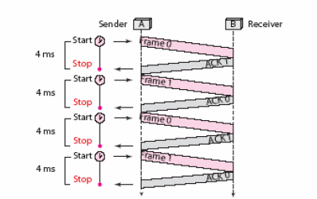

- What is difference between Stop-and-Wait ARQ and selective Repeat ARQ? [2]

In Stop and Wait ARQ we have to wait for ACK after each packet.
In Selective Repeat ARQ we can send packets without ACK depending on window size and similarly receive frames depending on window size.

- Using 5-bit sequence numbers, what is the maximum size of the send and receive windows for each of the following protocols? [6]

